Taylor Middle School Lunchtime Waste Study
March 13, 2018
Submitted by Teresa Montgomery, SSF Scavenger Company

Description:
Study was conducted inside the Shea Center on a rainy day. Trash cans were lined up in middle of room and lined with black bags. There were no recycling or organics/compost cans. The trash cans were not labeled with any instructions. Students cleared their own lunch waste before leaving. All trash cans were used but none were completely full. Staff emptied them after lunch was over. Green Team group randomly selected ed 4 partially full cans and sorted contents into the following categories: organics/compostables, recyclables, and trash.
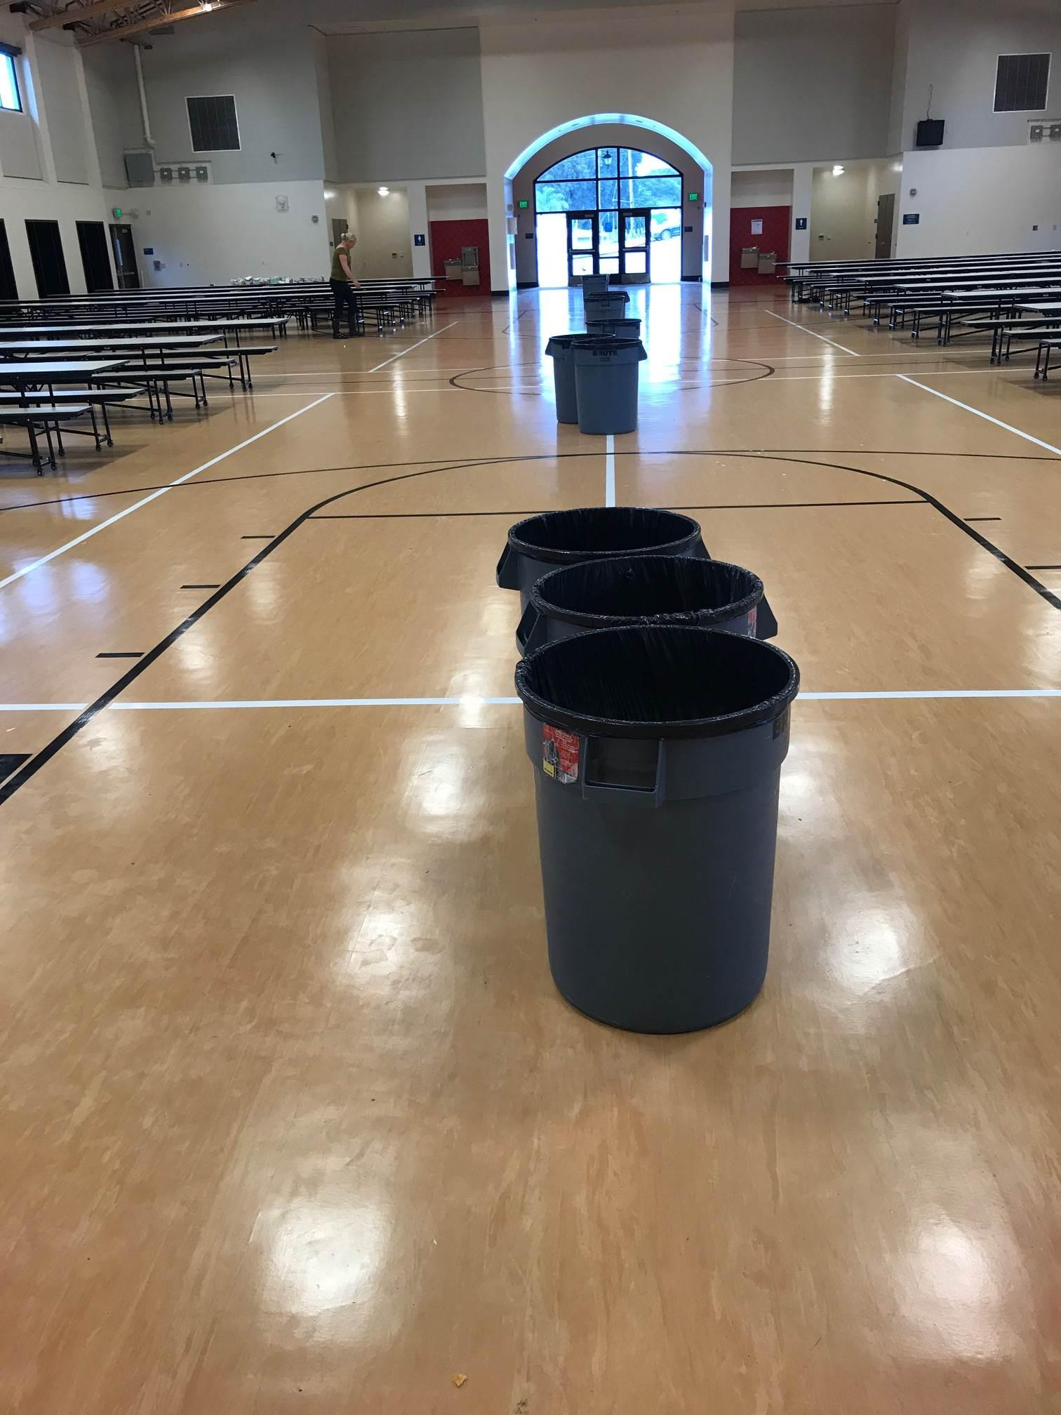
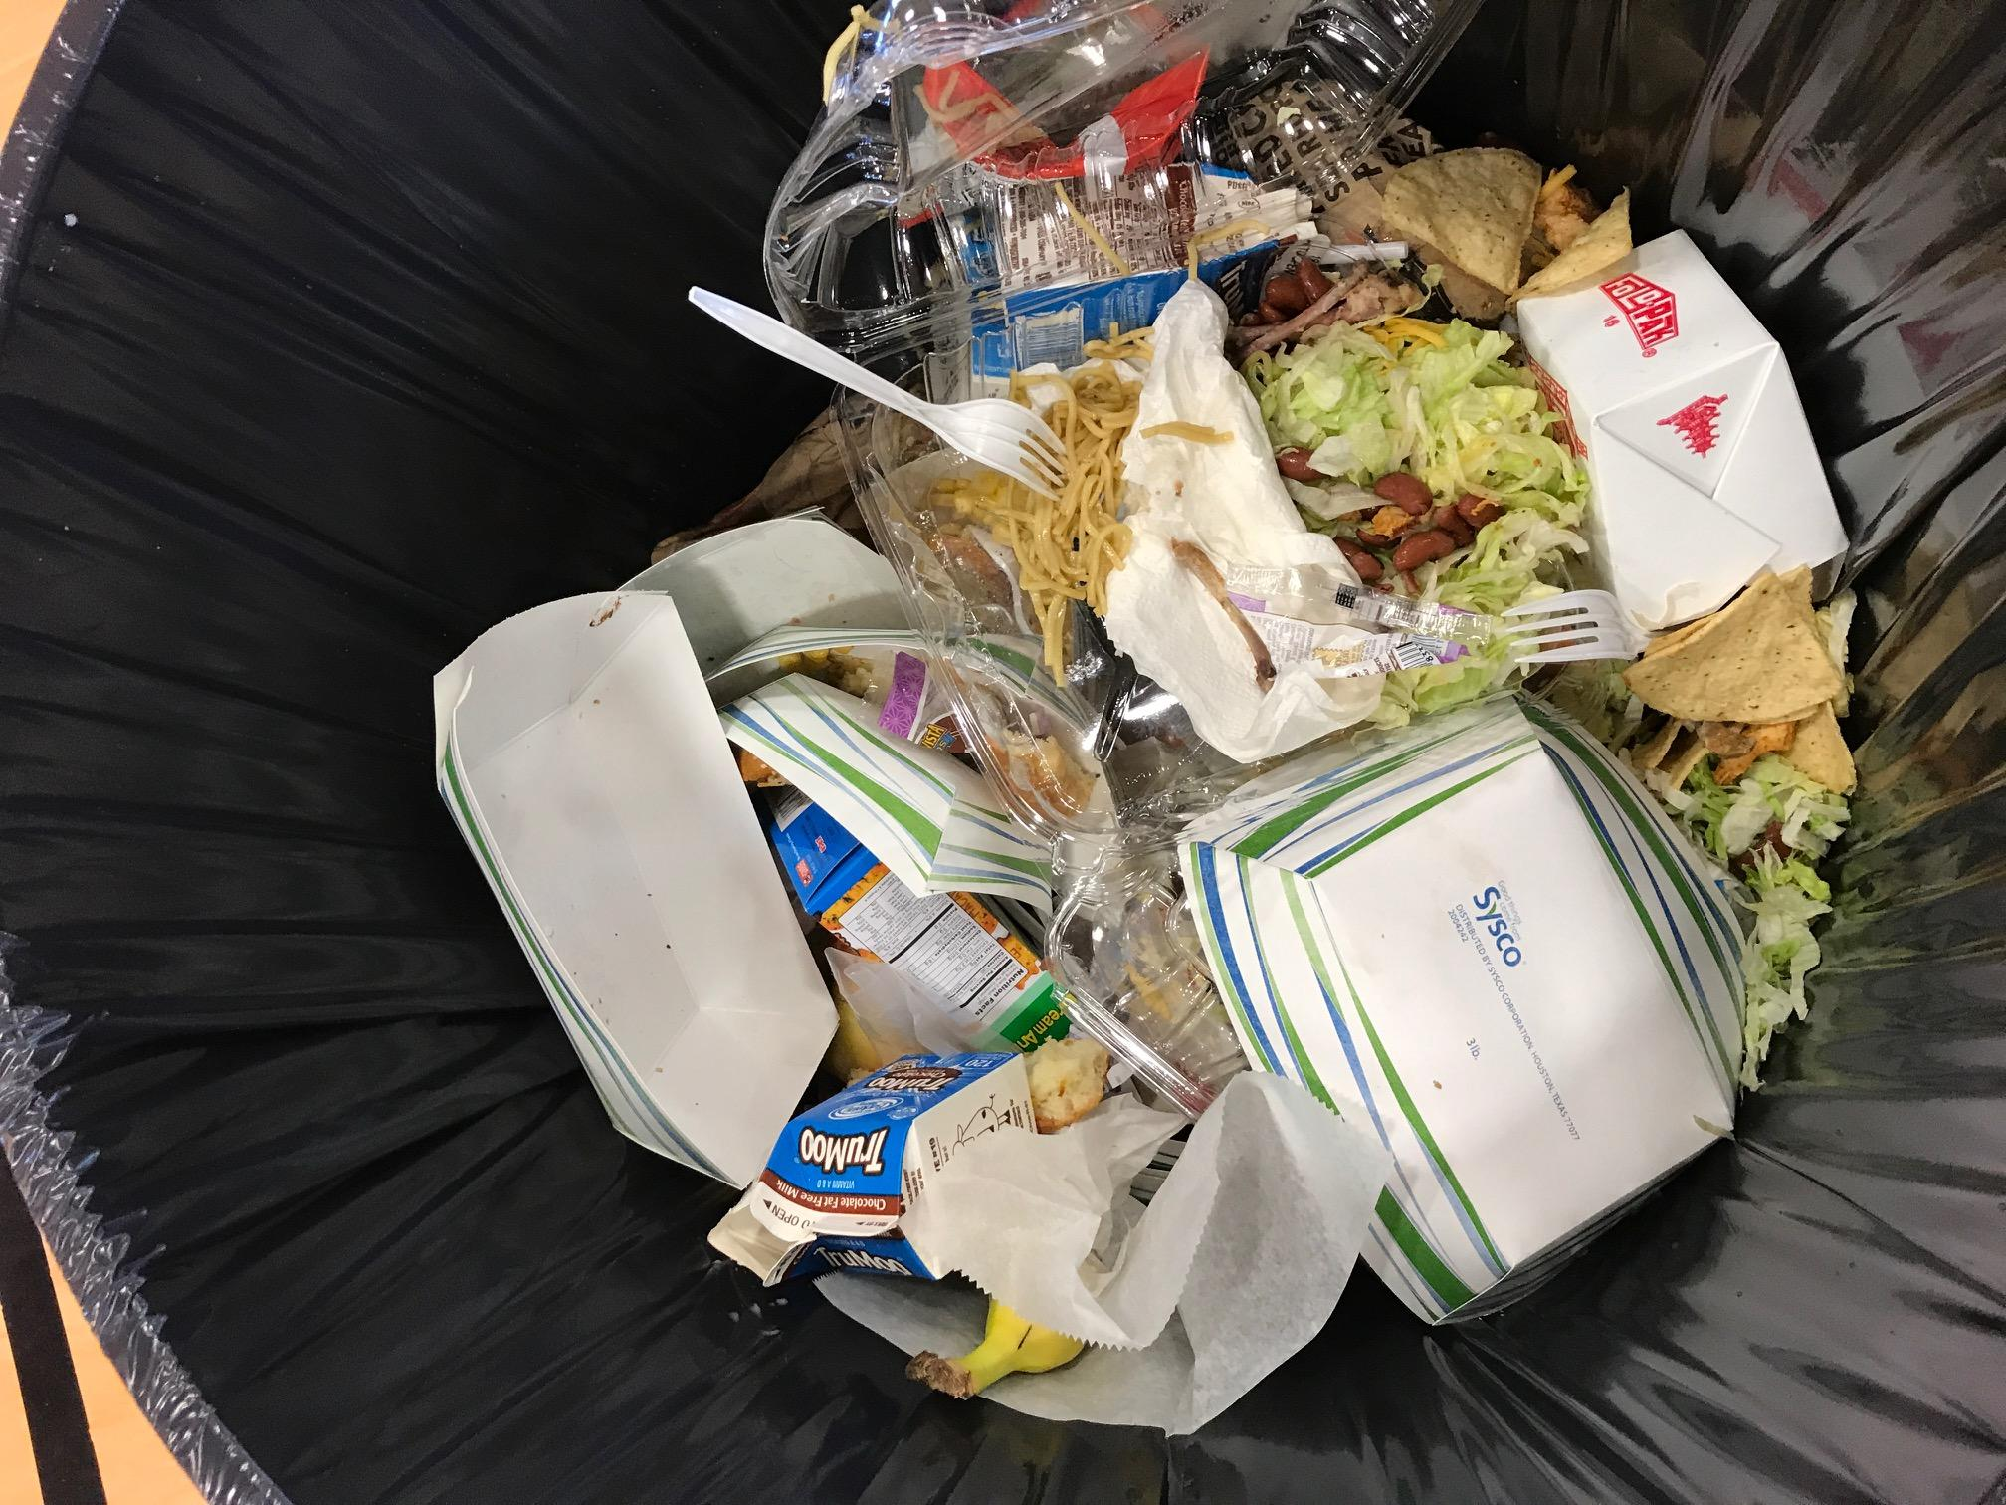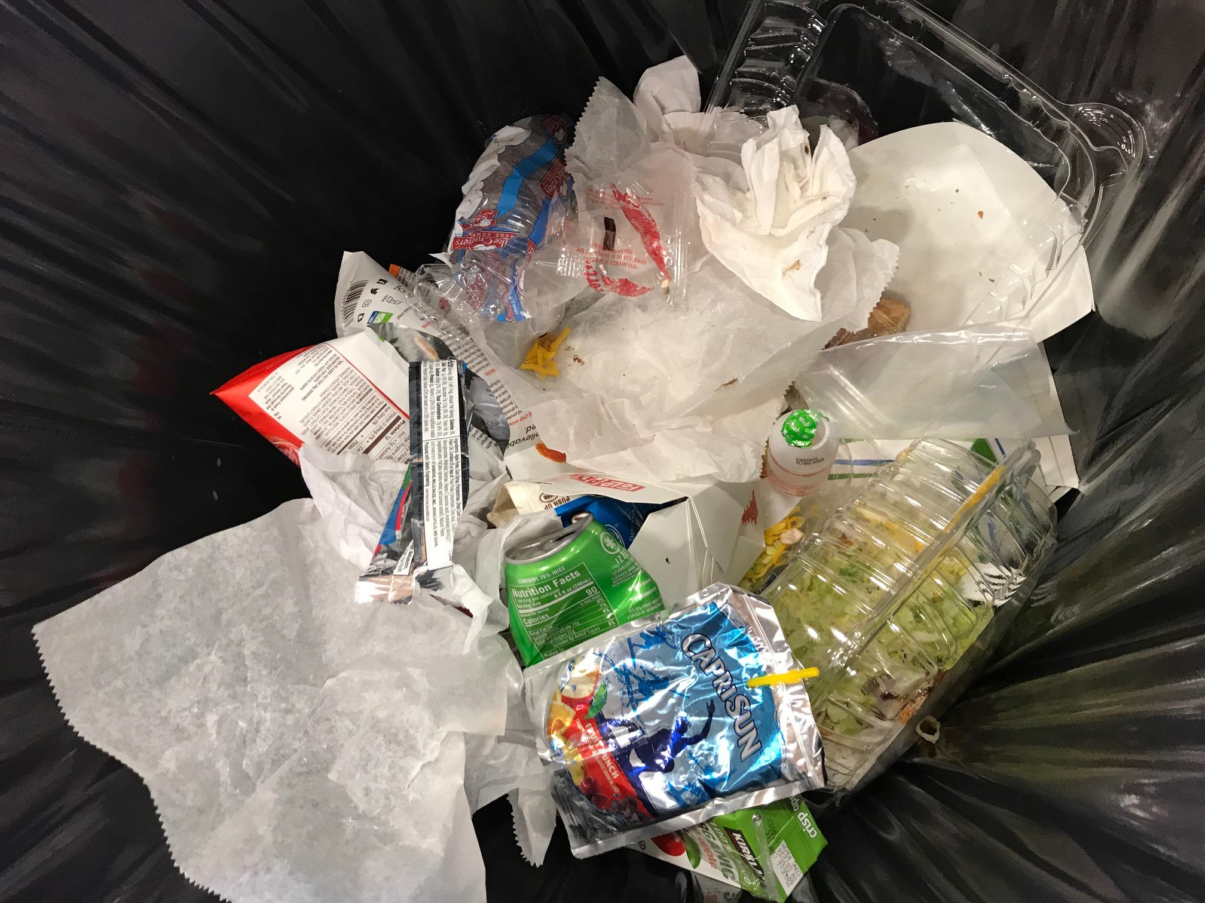

Findings:
Over half of the waste materials observed could be composted: paper trays, paper to-go boxes, paper napkins, brown paper bags, raisin boxes, milk cartons and food scraps.
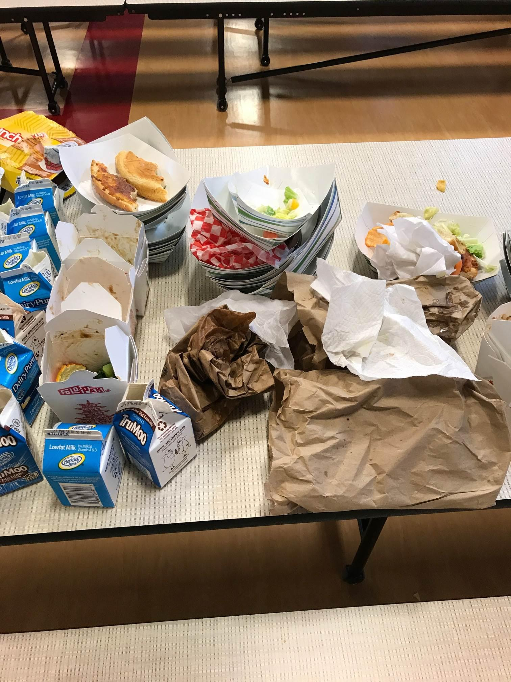
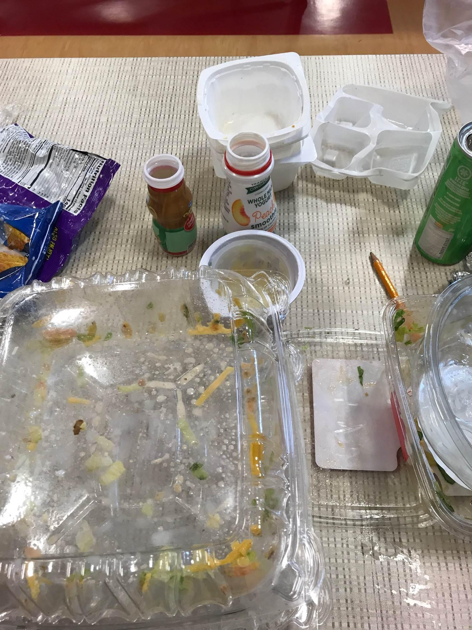
Approximately 10% of the waste materials observed could be recycled: rigid plastic containers (clam shells, bottles, trays, tubs & cups), aluminum foil, and aluminum cans.
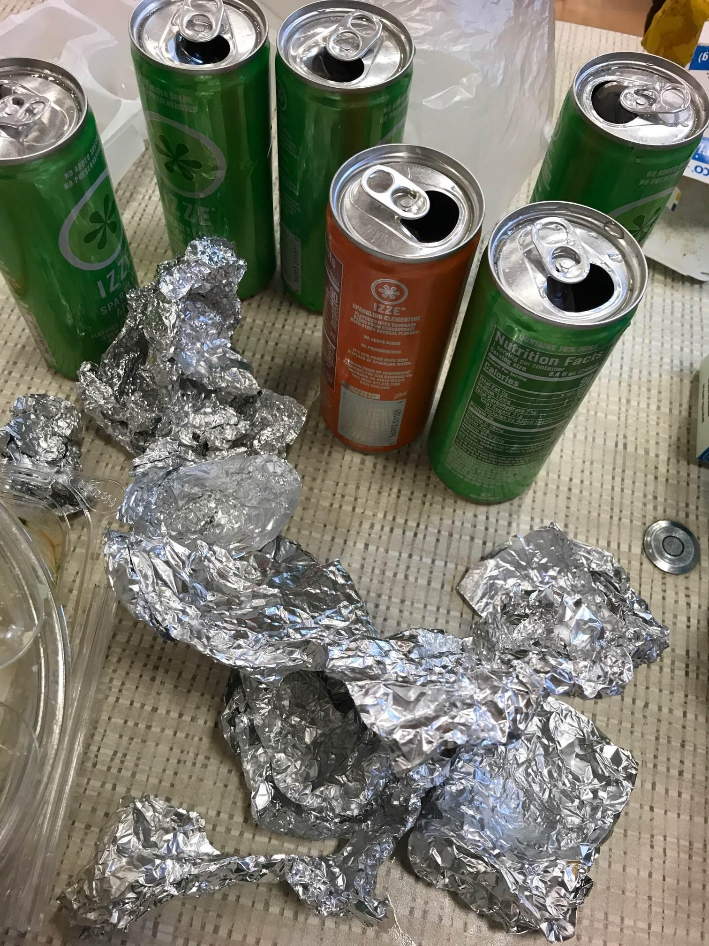
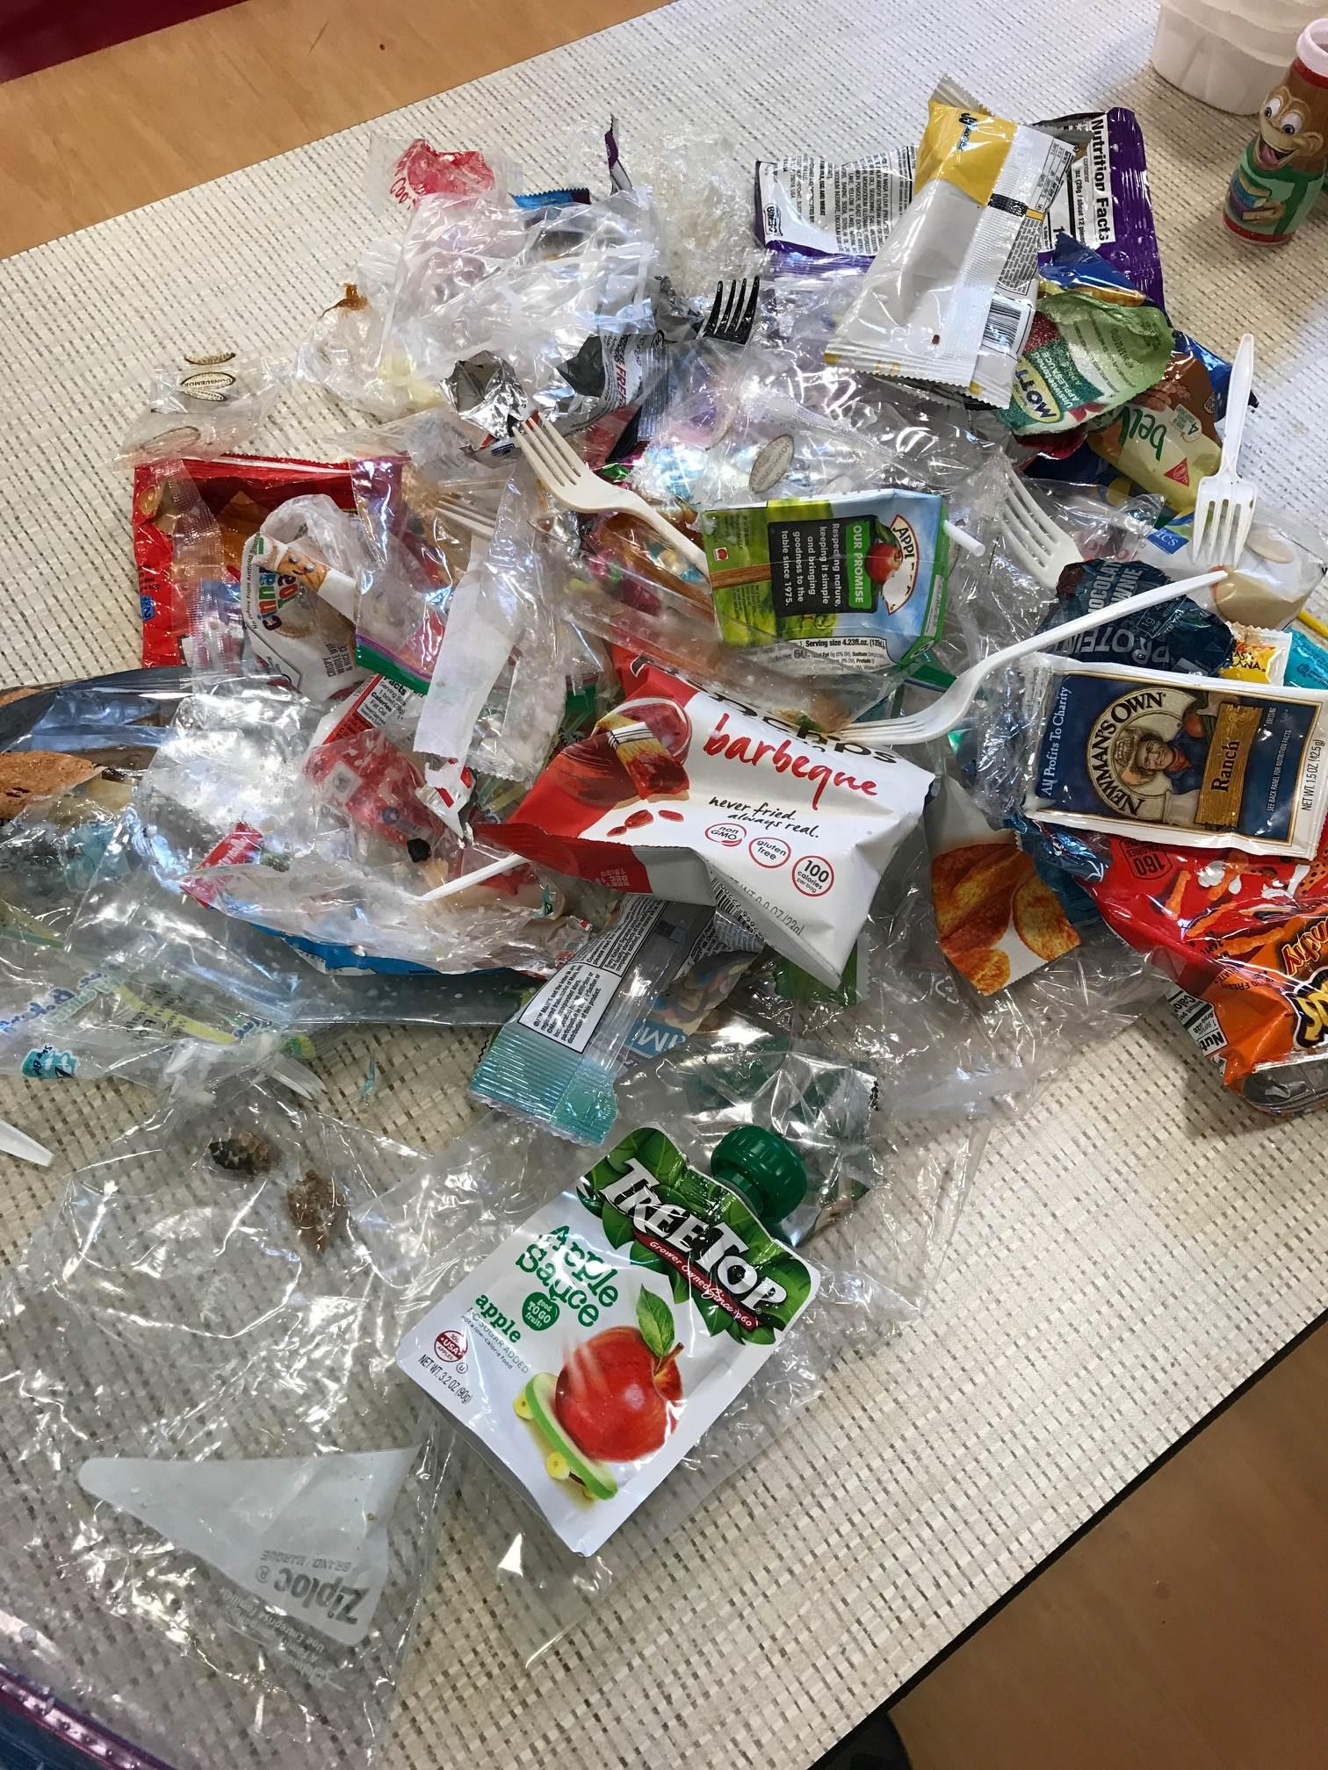
Approximately 30% of the materials observed were trash: Plastic bags and wrap, plastic chip bags (some resemble foil), plastic condiment packets, plastic utensils, plastic strays, juice boxes, Capri Suns, and apple sauce pouches.

Discussion Points:
Many of the items found in the trash could be avoided. Buying in bulk, selecting items with compostable or recyclable packaging, and consistently using reusable containers and utensils would considerably reduce the amount of trash created.
Milk cartons are a significant portion of the waste stream—especially by weight since most are not empty. If the cartons were emptied, the milk could safely be put down a sink drain and the cartons placed in an organics bin for composting. Full cartons can be put directly into an organics bin but the liquid will cause liner bags to break and make a mess that could be problematic.
Paper food trays are another significant part of the waste stream. They are easy to compost and will absorb moisture and odor inside an organics collection bin. If collected in stacks, they will take up less space in the collection bin.
Aluminum cans and foil, and rigid plastic containers are a small part of the waste stream but it is imperative that these be recycled and not landfilled. Cans and bottles with CRV are worth $ if taken to a buy-back center. If the Green Team were to do a special collection of CRV items, and deliver to a buy-back center, the $ could be used for club activities.

Suggestions for next steps:
Provide recycling and organics collection cans in the lunch area(s)—if possible, use gray or black for trash, green for organics, and blue for recycling. Put signs on every can so it’s easy for students to see what belongs inside. Custom signs showing waste items specific to your school work best.
Work with cafeteria/custodial staff to make sure correct liner bags are used. Black bags are fine for the trash. If organics will be bagged, use a certified compostable option. Recyclables should be placed loose (no bags) in the large recycling containers emptied by SSF Scavenger.
Provide buckets for collection of milk—with a screen or funnel to prevent splashing and spills. Work with cafeteria/custodial staff to make sure these are emptied down an appropriate sink drain.
Work with SSF Scavenger to make sure the custodians have adequately sized recycling, organics and trash collection bins to empty lunch area waste cans into.
Develop a plan for ongoing education—lunch time “trash talkers” that stand by the waste collection cans, presentations to classrooms or at assemblies, video clips, posters, etc. Remember that the 4Rs are listed in order of importance: Reduce, Reuse, Recycle, Rot (compost).
Encourage waste reduction—teach students to pack waste-free lunches, ask cafeteria staff to use condiment dispensers instead of giving out single-serving packets, and set up a table or basket for sharing food.

